Pokhara University

Level: Bachelor | Semester – Spring | Year : 2006
Programme: BE |  | Full Marks: 100
Course: Chemistry |  | Time : 3hrs.

Candidates are required to give their answers in their own words as far as practicable.
The figures in the margin indicate full marks.

Attempt all the questions.

 | - What are the main assumptions of Bohr's atomic model? Calculate the wave length of second line in Balmer series (Rydberg constant = 1.097×10⁷m^{–1}).  - Derive de-Broglie's equation. Calculate the wave length of a stone of 500 g mass moving with a velocity of 20m/s. | 5+3  4+3
 | - Define and derive Ostwald's dilution law for the ionization of a weak electrolyte. A buffer is made by adding 500ml of 0.3M acetic acid in 400ml of 0.5M sodium acetate. Calculate the pH of resulting solution and pk_{a} for acetic acid = 4.74  - What do you mean by Standard Hydrogen Electrode? Calculate the emf of the following cell at 27ºC.  Cd/Cd⁺⁺ (a = 0.3) // Ni++(a = 0.5)/Ni  E_{oCd/Cd++} = +0.403V Eo_{Ni++/Ni} = – 0.25V  Gas constant, R = 8.314JK ^{–1}mol^{–1}  Farady constant, F = 96487 Cmol ^{–1} | 8  3+4
 | - Give reasons, why:  - Second ionization energy is greate than first ionization energy  - Ionisation energy of nitrogen is greater than oxygen  - Electro affinity of chlorine is higher than fluorine  - Electro negativity of seventh group element is the highest  b) Write characteristic feature of s and p block elements.  OR  - Define electronegativity. Discuss the factors affecting the values of electronegativity. Why second electron affinity value is always positive?  - Explain why the compounds of d-block elements are coloured whereas s and p block elements are colourless. Write any three properties of transition elements. | 4×2  7  1+5+2  4+3
 | - Explain hydrogen bonding with suitable example. What are the main differences between Valence Bond Theory and Molecular Orbital Theory?  - What is hybridization? Explain different types of hybridization and also explain the shape of water molecule on the basis of hybridization. | 3+4  8
 | - Write the IUPAC Naming of following organic compounds:  - CH₃CH₂CHO  - CH₃CHOHCH₂COOH  - CH₂BrCHBrCHClCH = CH₂  H₂N  COOH  - Differentiate between carbocations and carbanions.  - What are the differences between enantiomers and diasteriomers? | 5×1  5  5
 | - Write the mechanism of following reactions:  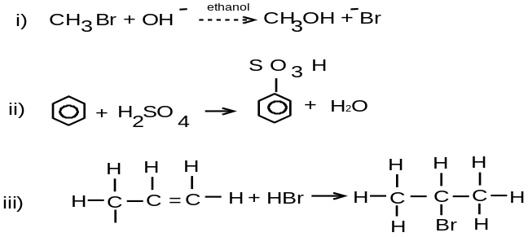  - Give Reasons:  - Thermosetting plastics are rigid in structure.  - Thermoplastics can be mould into different shapes.  - Condensation polymerization is called step growth polymerization.  OR  - Write the mechanism and stereochemistry of first order nucleophilic substitution reaction.  - Differentiate between E₁ and E₂ reactions. | 3×3  2×3  7  8
 | Write short notes on (Any Two):  - Air pollution  - Inductive effect  - Racemic mixture  - Determination of hardness of water | 5×2

